1. Npm - - version -> check node version, use vite package to create react (npm create vite@latest) ->y->project name: profilio -> pick react ->pick javascript+swc, open profilio folder, open terminal, type npm install (install all dependency from package.json) -> npm run dev, main.jsx is main react project, app.jsx return html by using javascript
2. Firstly clean app.jsx, delete everything, type rafce, delete first row (react), go to src to create components folder, create Profilio_Index.jsx, type rafce, remove react import, go to app.jsx to add <Profilio_Index />, it is in the centre because of app.css, clear all content of app.css and index.css, after that ,create About, Contact, Experience, Testimonials, Services, Header, Footer, Nav and Profilio_P folders and individually create Profilio_About.jsx/css, Profilio_Contact.jsx/css, Profilio_Experience.jsx/css and Profilio_Testimonials.jsx/css …in each folders and import related files. Implement all components to Profilio_Index.jsx and check browser,

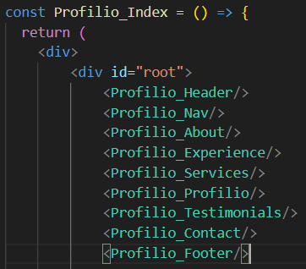 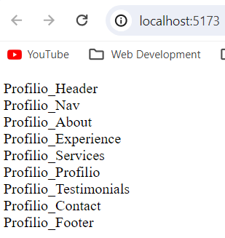

1. Back to Profilio_Index.css to change font by using Google font, firstly add some default css as follow, and then go to google fonts, select Poppins and import to css, check browser and font changed, add some css to body, now setup general css,

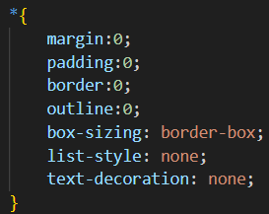 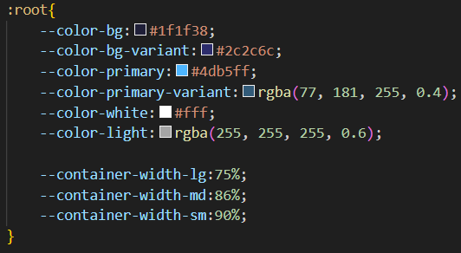 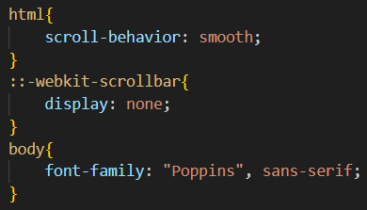



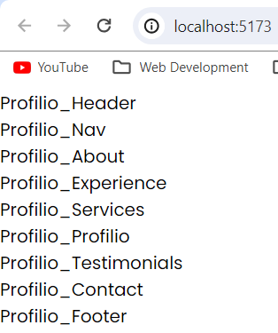 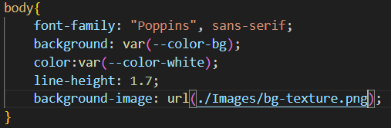 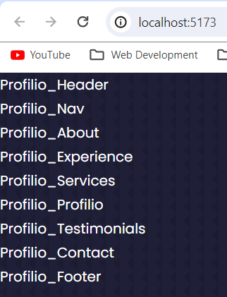

1. General style as follow

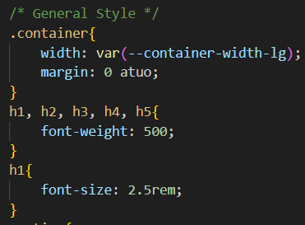 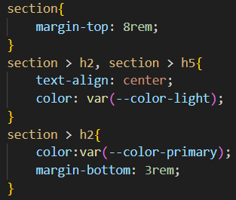 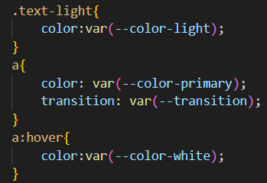

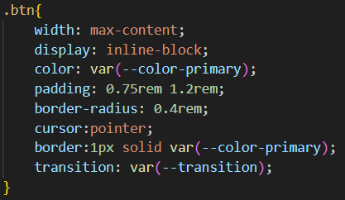 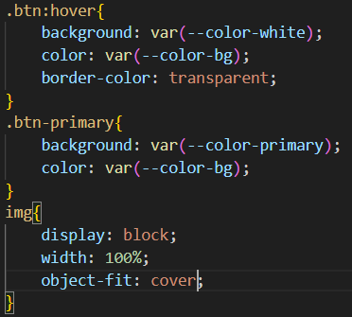

1. Media query

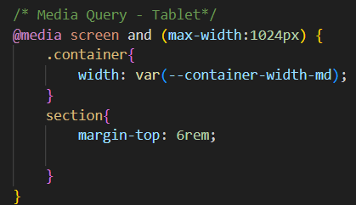 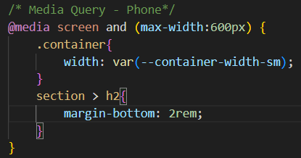

1. Start to write Header, add CTA.jsx in Header folder for header button and write CTA code (download is working), add class btn to Download CV and class btn btn-primary to Let’s Talk, after that, add new div with class me and place img with me.png under <CTA>, create HeaderSocials.jsx for scroll down, and add class header__socials in div, create 3 a links and we will use react icon (<https://react-icons.github.io/react-icons/>), create new terminal and paste ‘npm install react-icons –save’ , back to react-icons page to search linkedin, github, dribble and paste code in HeaderSocials.jsx, now back to Profilio_Header.css to style them, then style image, then style class scroll down, and then write code for Media Query

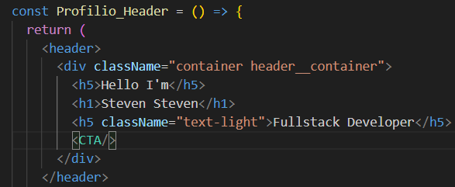 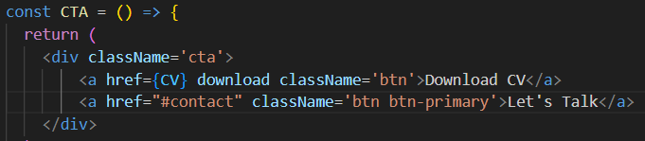

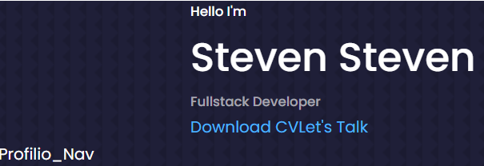 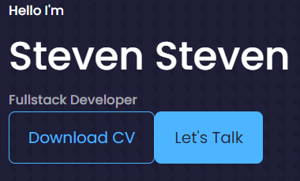 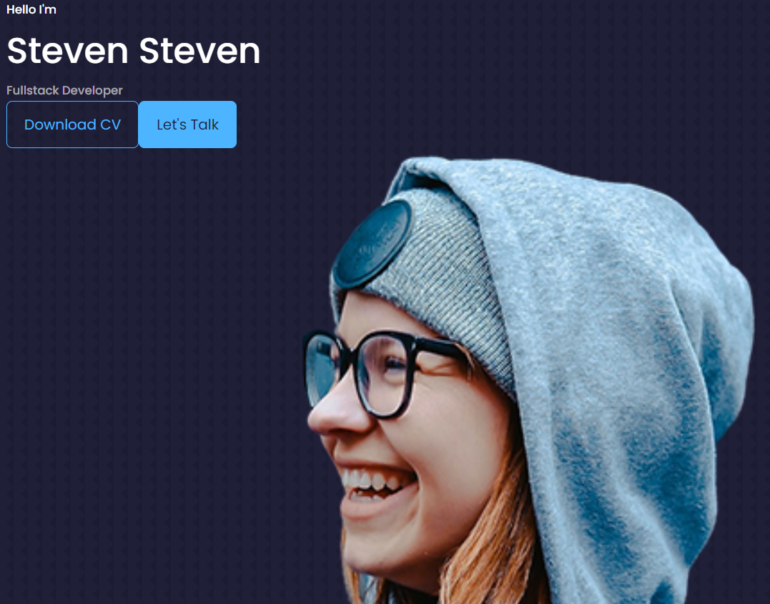

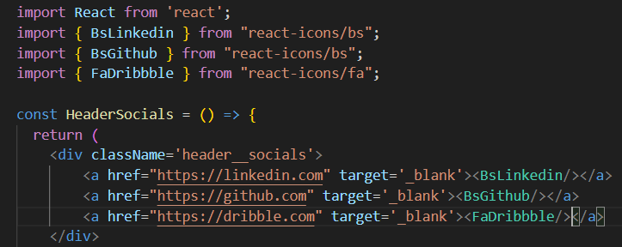 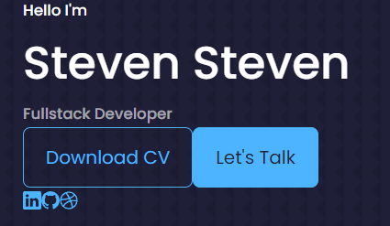

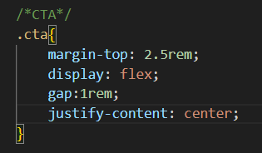 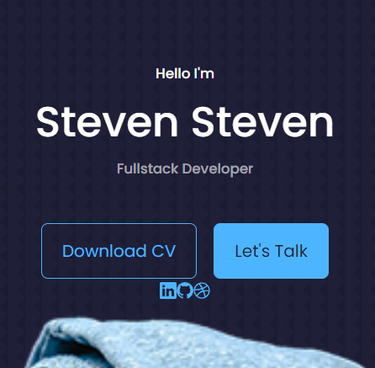 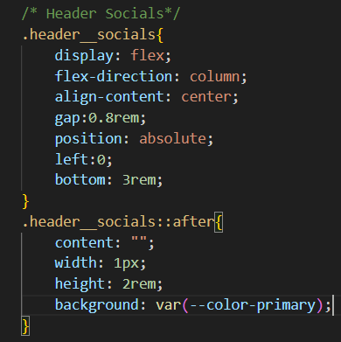 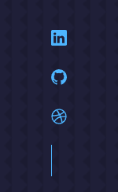

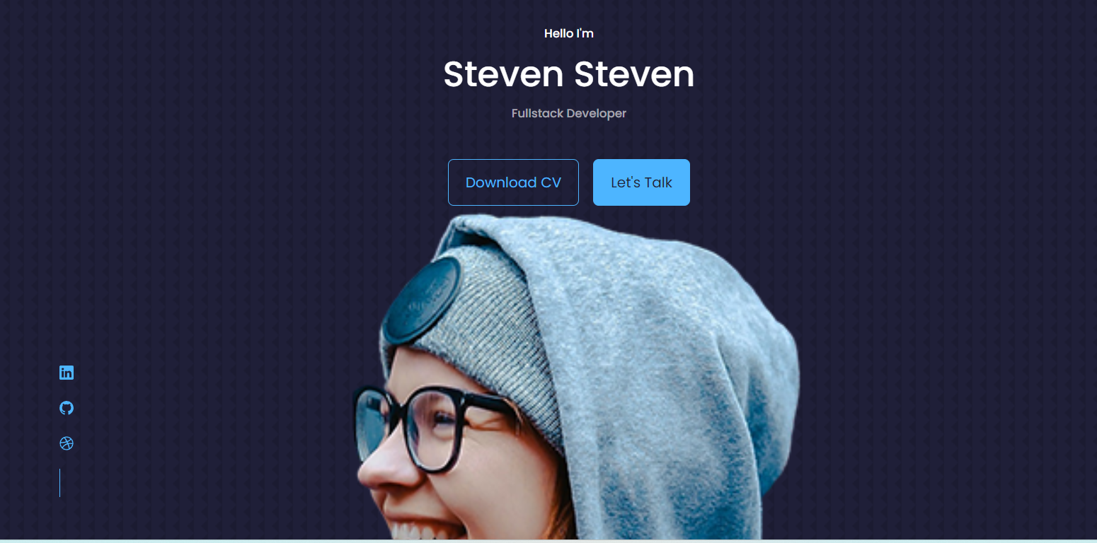 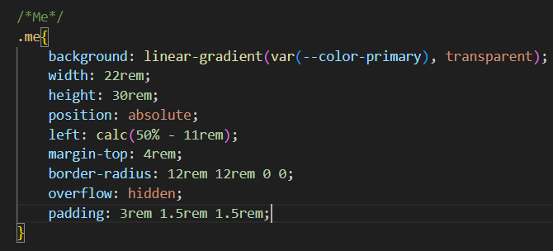 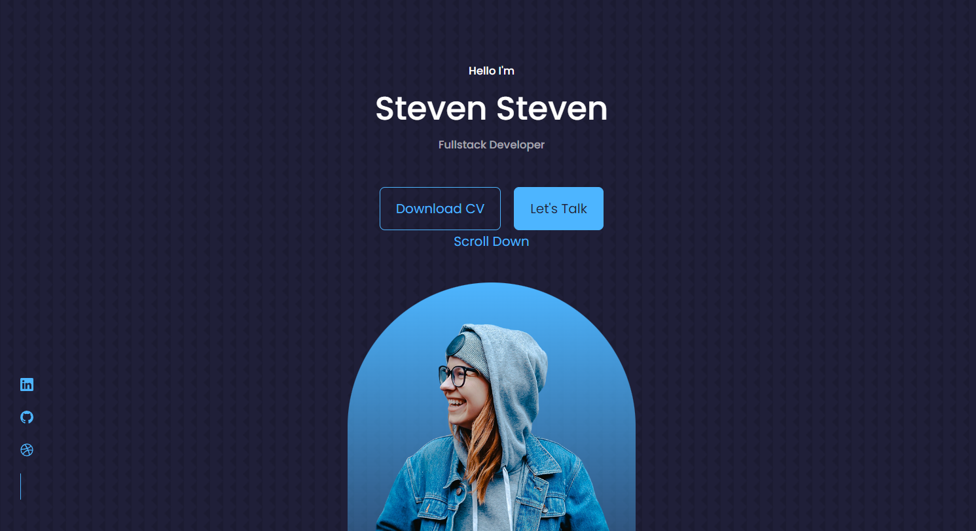 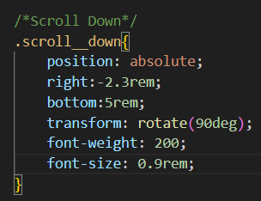 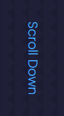

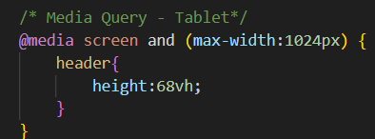 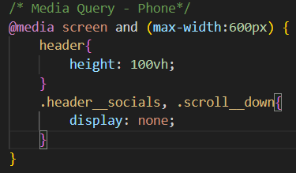

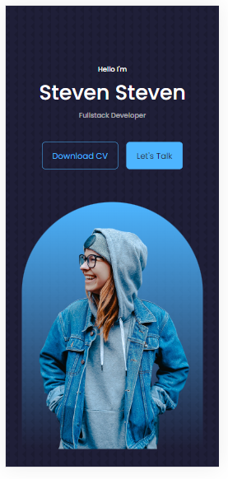 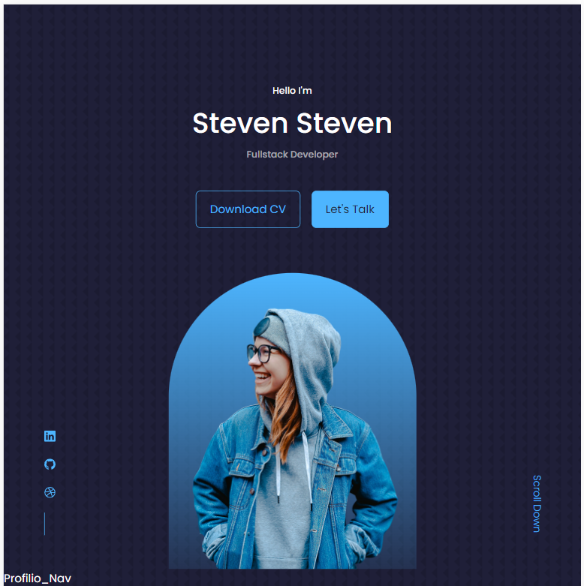

1. Now start to write code for Nav, open Profilio_Nav.jsx, change div to Nav, add a link and back to react icon and add Profilio_Index.css section hiehgt:100vh (change different jsx file from div to section tag, after that, style Nav in Profilio_Nav.css (add className as active in home link), to change different active by using useState, tested it on browser and it worked, that’s all for navigation bar.

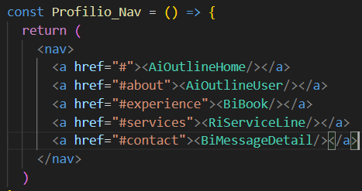 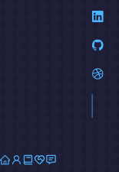 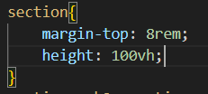

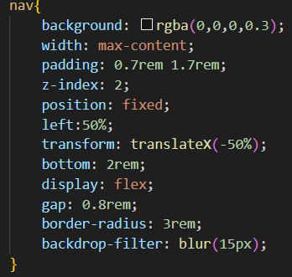 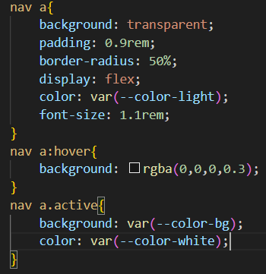 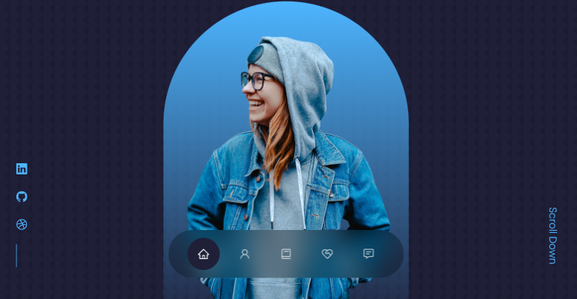

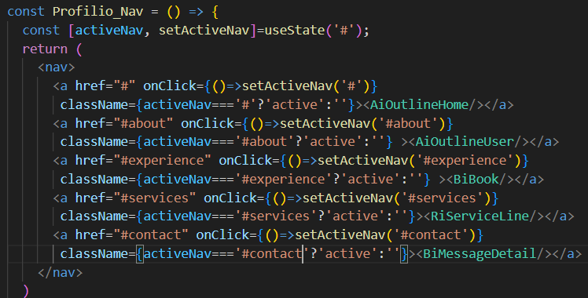

1. Next will go to about, open Profilio_About.jsx, code the structure(about__conatiner, about__me/about__me-image, about__content/about__cards/about__card), after that, go to react icon to search relative icons to place in each article, add <p> by using lorem( code lorem30 will display 30 words), then go to Profilio_About.css to style them, firstly use grid to set structure and style left side of image, afterward, style right side for cards, and check browser , it worked well, now add media query and check browser, next move to experience section

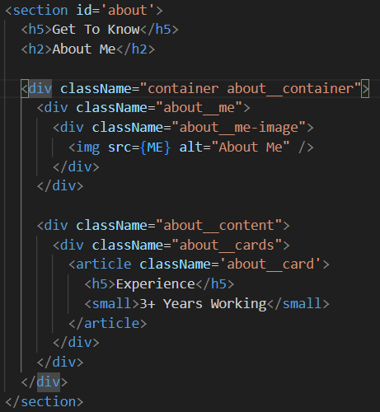 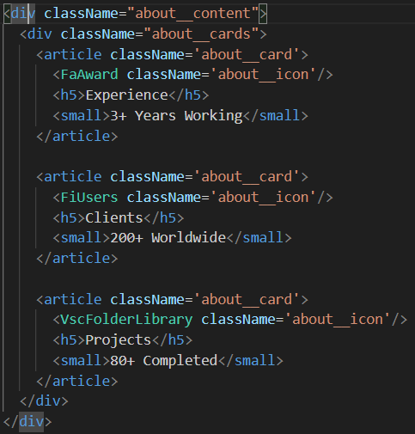 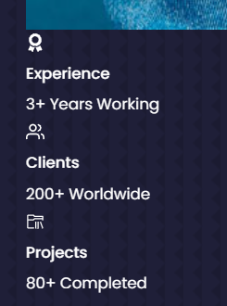



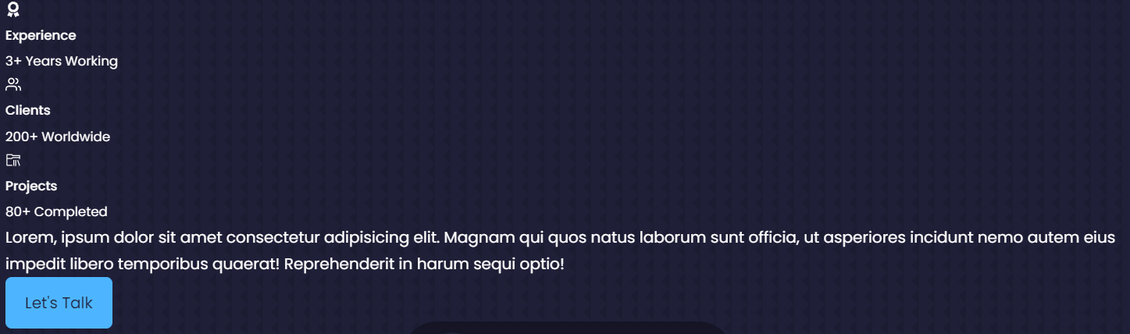

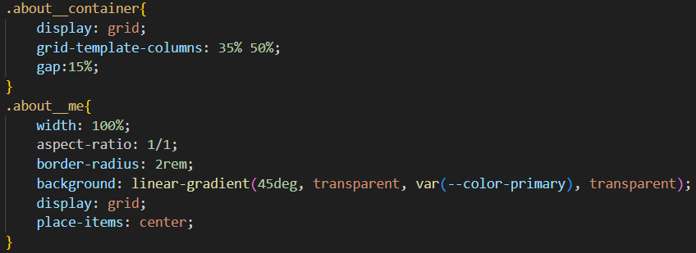 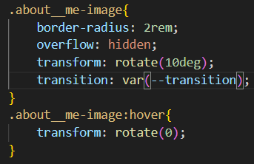

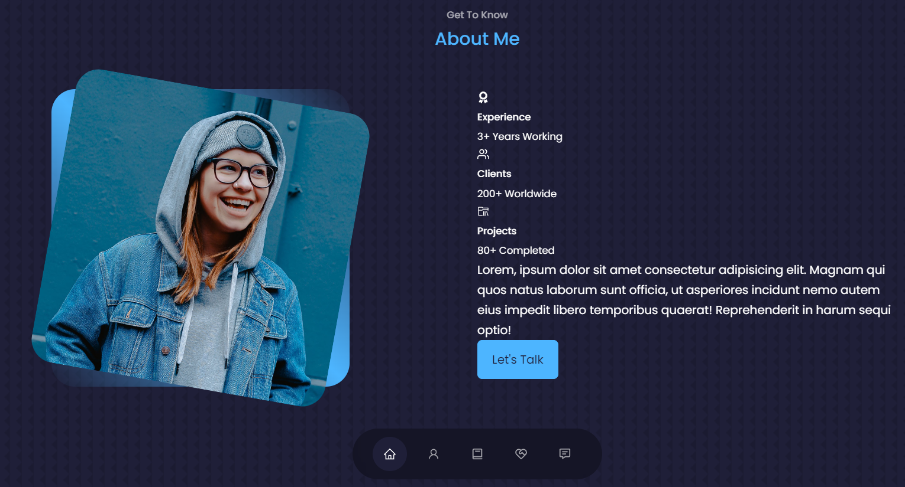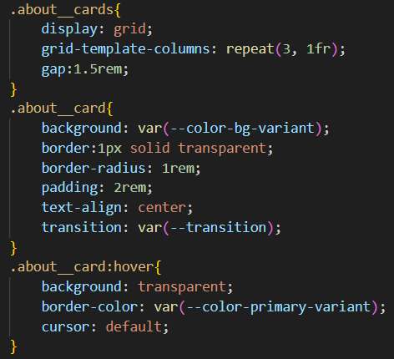 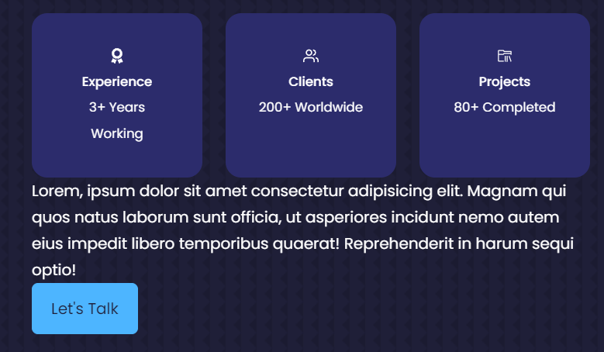 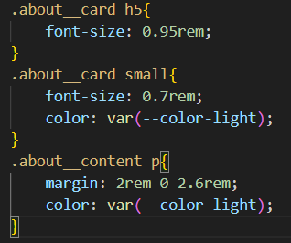 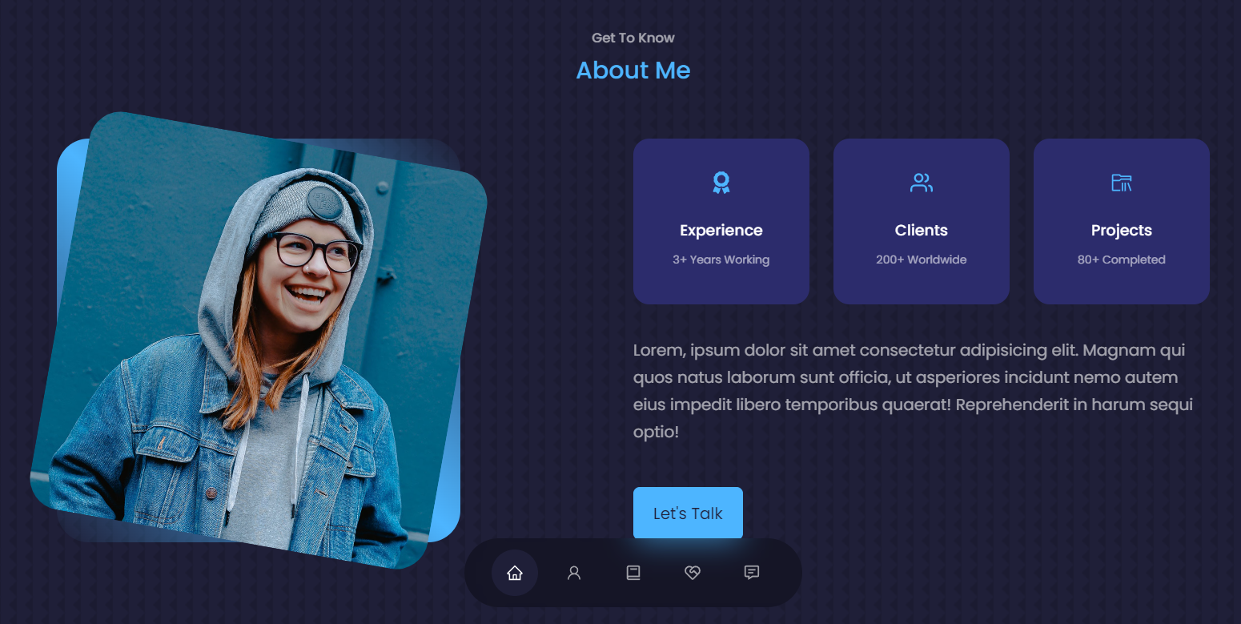

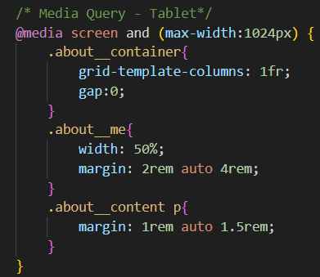 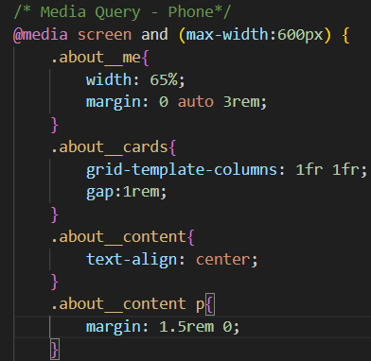 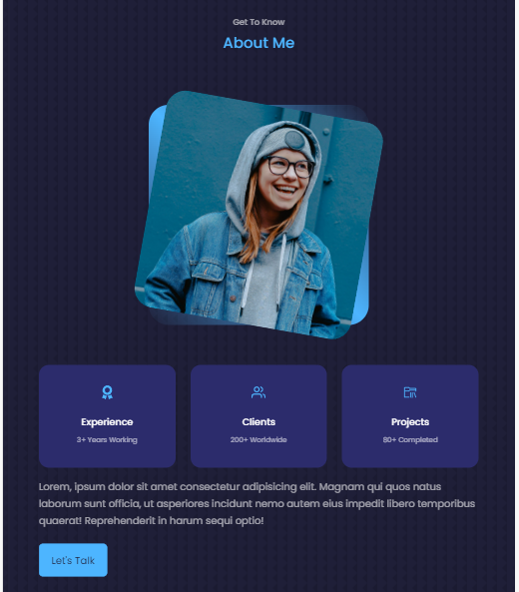 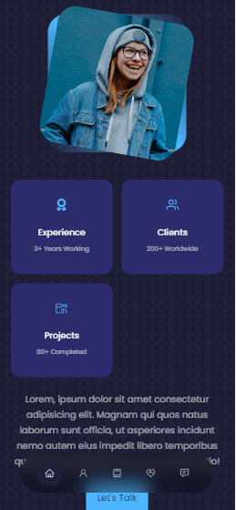

1. Move to experience folder, open Porfilio_Experience.jsx to build the structure first, and then back to React icon to search relative icons and completed card content, afterward, move to CSS part and check browser, it worked well, now add media query in css, remove Profilio_Index.css section high, and check browser.

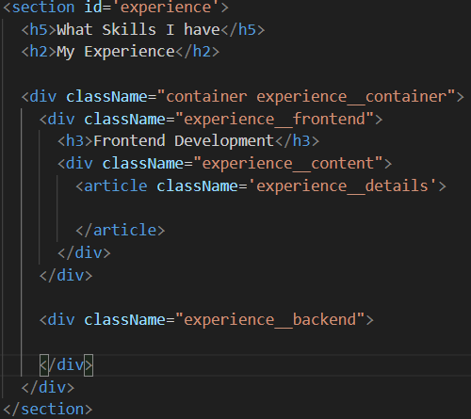 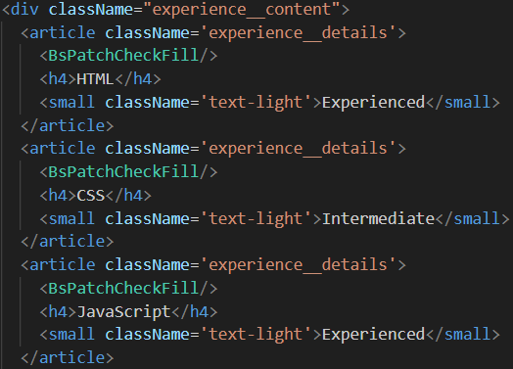

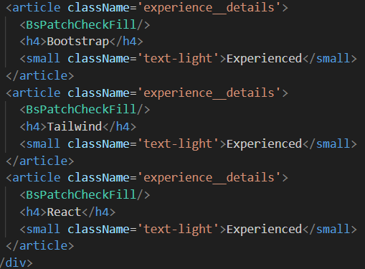 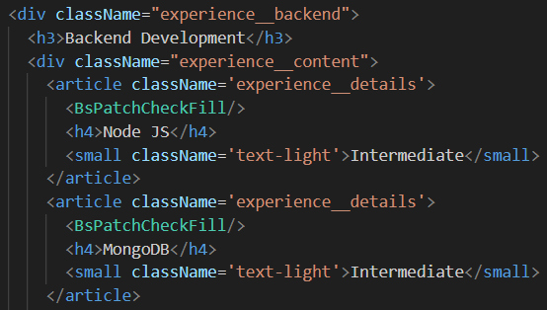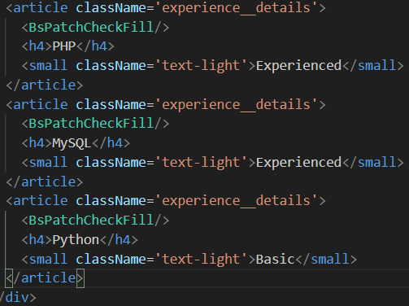 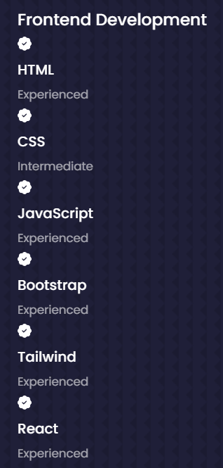 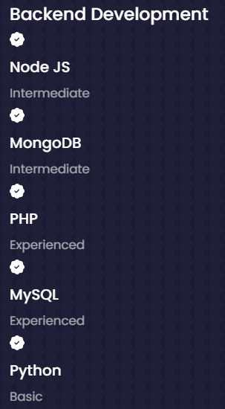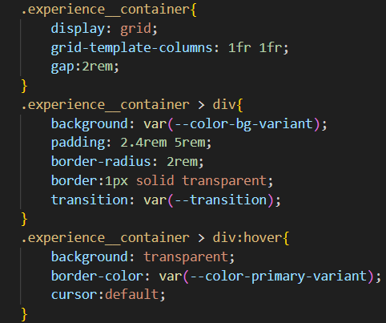 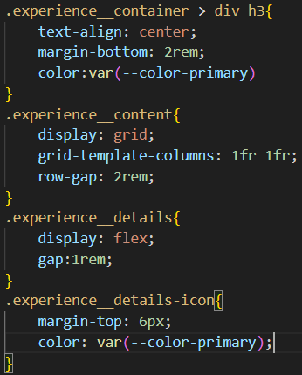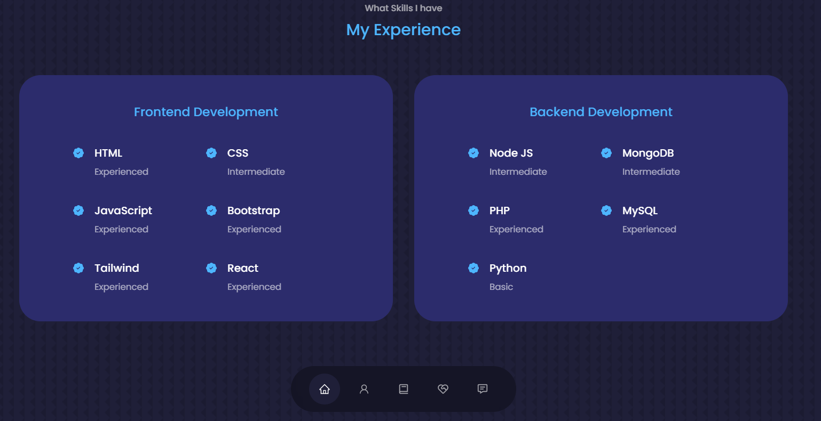

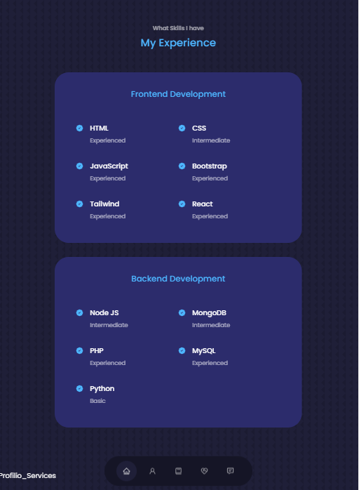 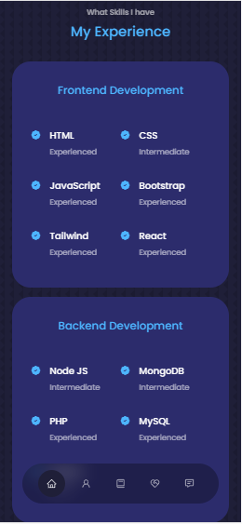

1. Next move to Services, open Profilio_Services.jsx, build the structure, copy twice as below, and then go to style sheet and check browser, after that, add media query and check browser.

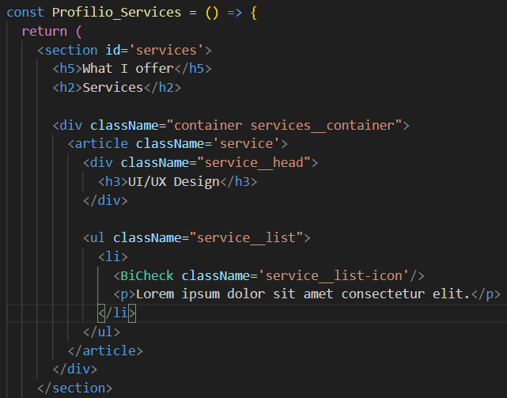 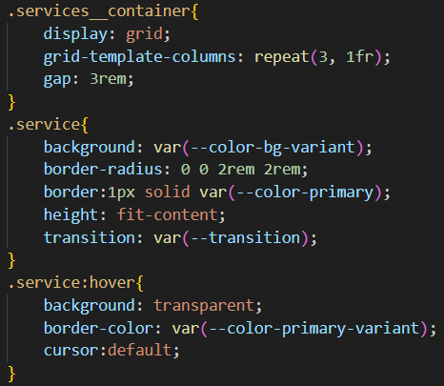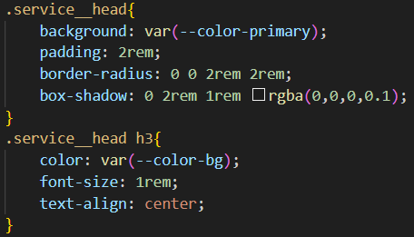 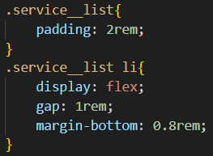 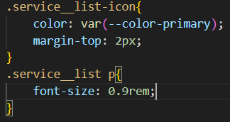

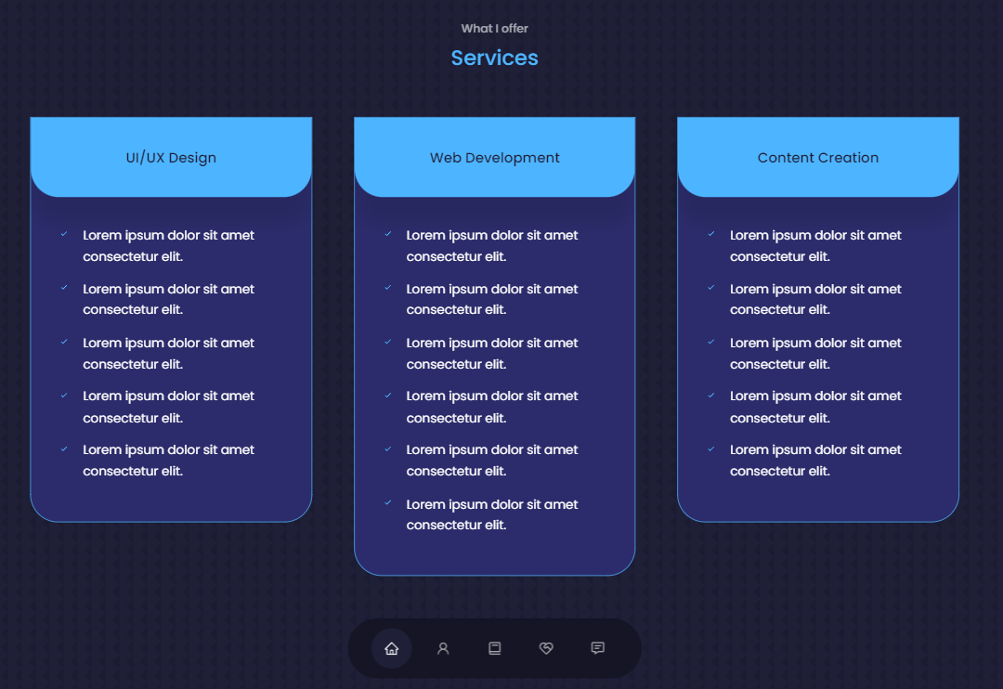 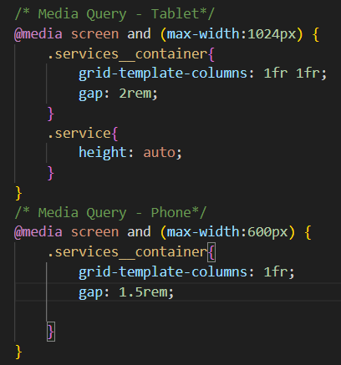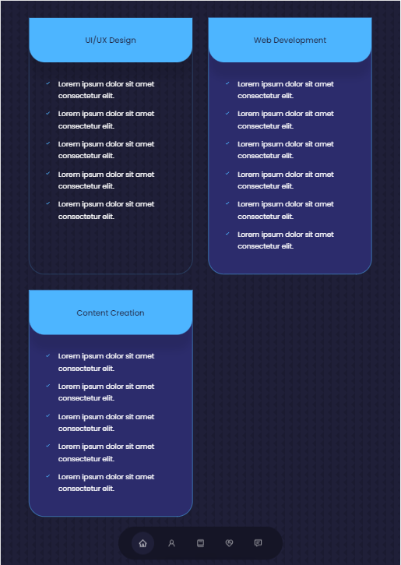 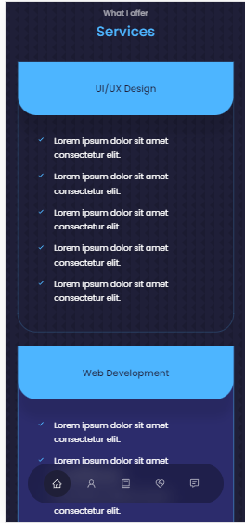

1. Next move to Portfolio, create the structure, and add github to link(you can add your github project) and go to dribble(<https://dribbble.com/alien_pixels>) to copy url to your code and import image to your code, and then copy your article for 5 times and change the detail, and then go to CSS to style them, afterward check browser, add media query for different devices, now we are going to use array mock function to generate article, add array, and just keep one article and delete all other articles, add data.map() function to get all data from array,

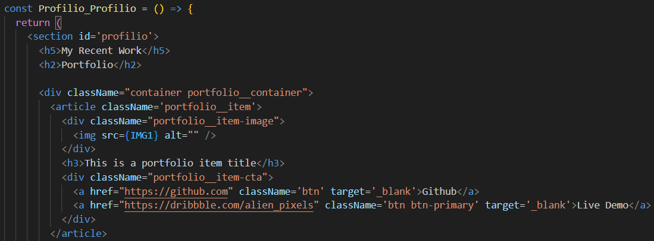

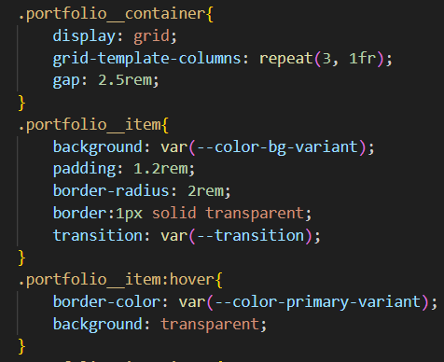 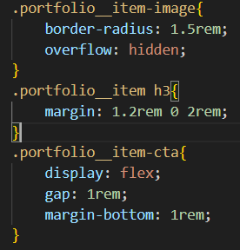

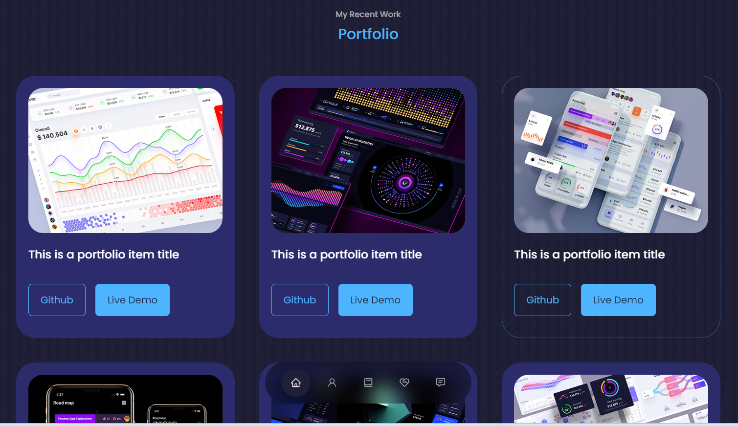

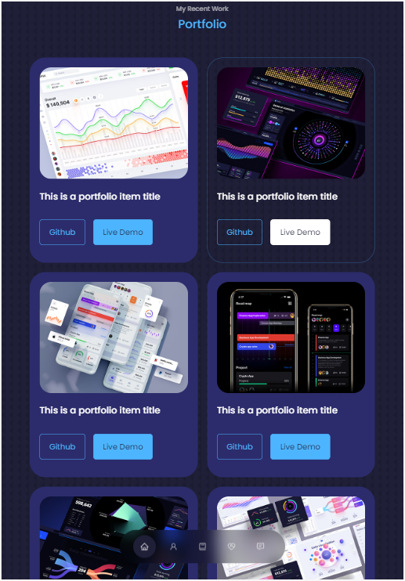 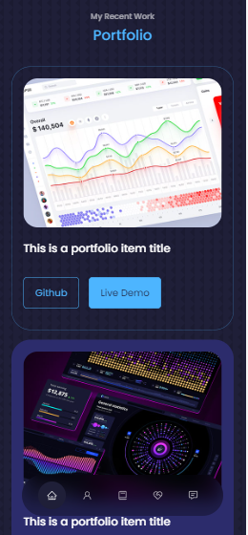

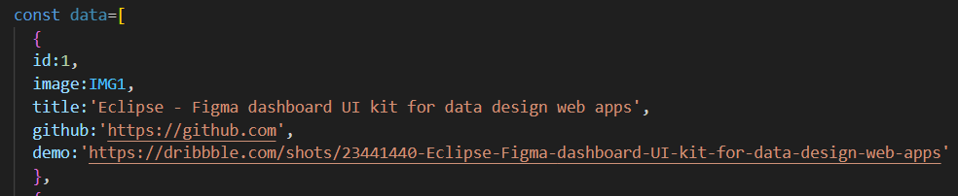

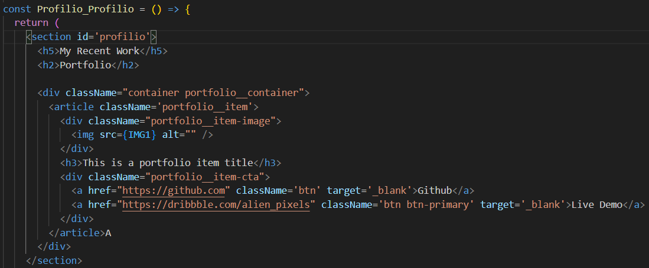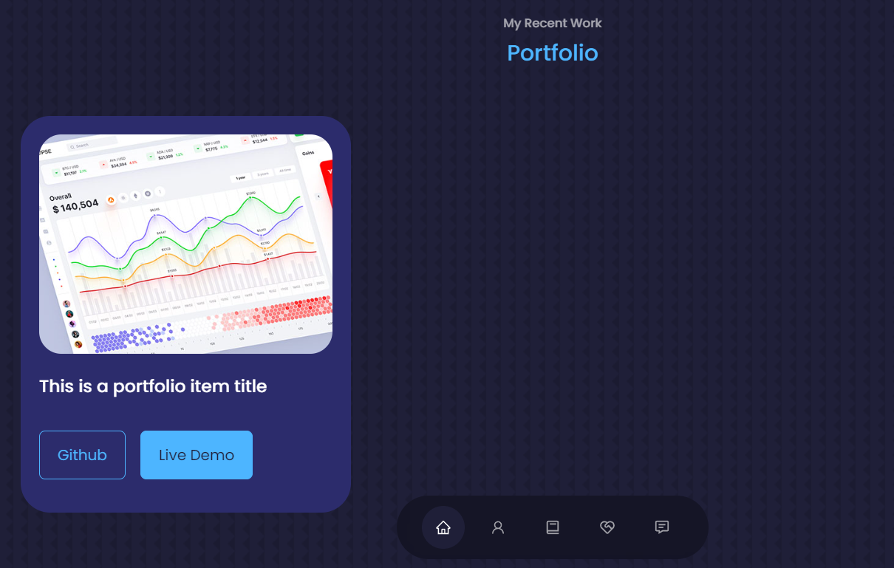 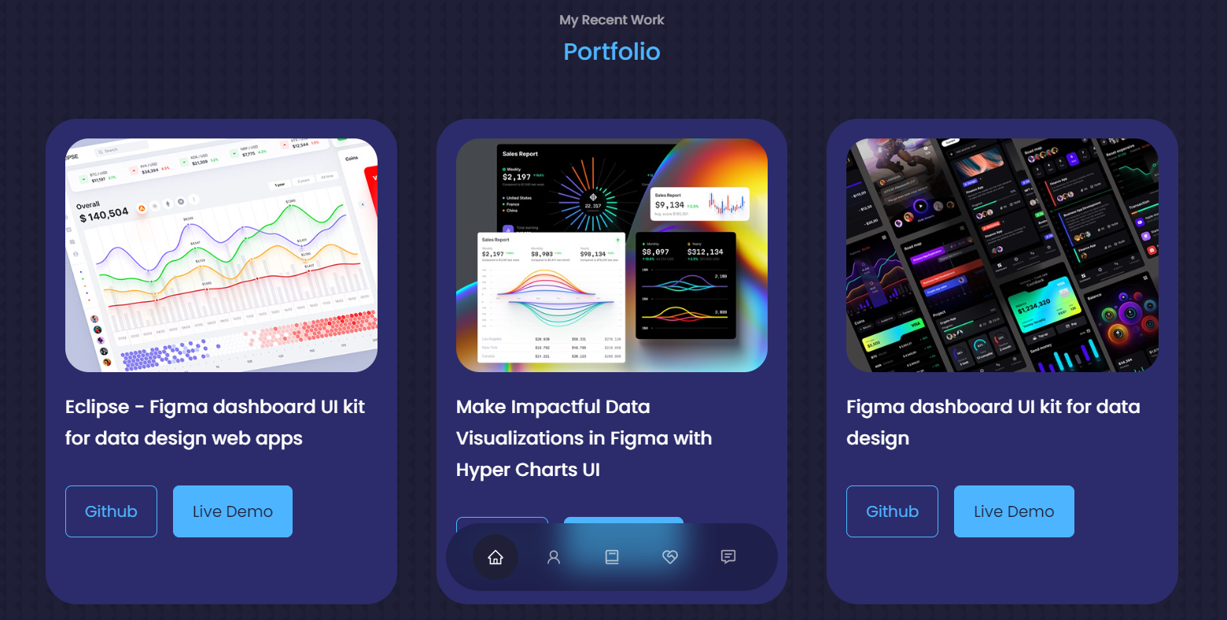

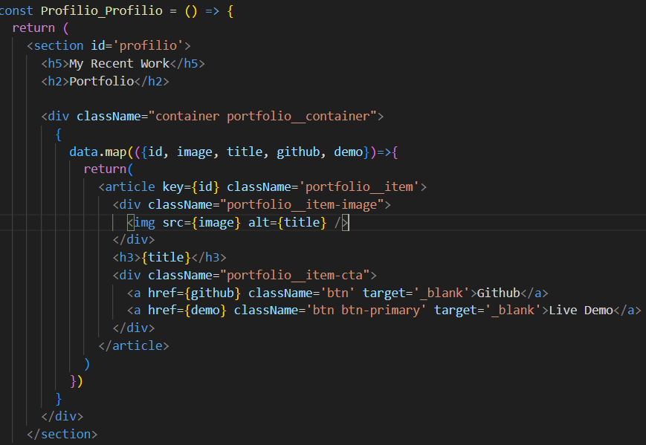

1. Next move to testimonials, open Profilio_Testimonials.jsx, built the structure and copy article 3 times(later will also use array to generate them), now open its css to style them, write media query first, after that, paste avatar data array to code, keep one article and remove others, now we are going to swiperjs.com to use slide function, click on react( you can see demo to see how it work, swiperjs.com/demos), firstly we need to install swiperjs to the project (npm i swiper) and then import related functions, change div to Swiper tag and change article to Swiperslide and add default code from swiperjs website, check browser and it worked well.

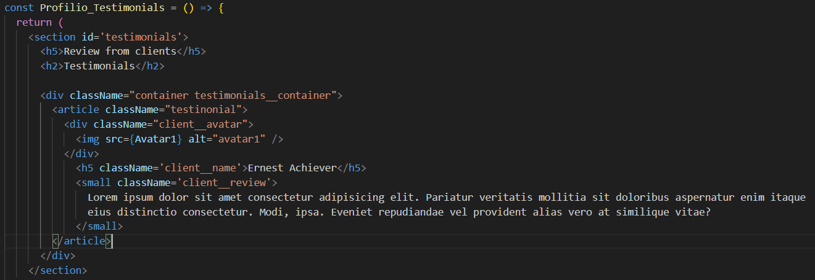 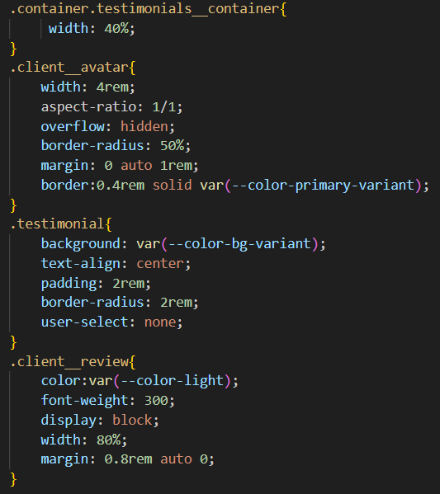 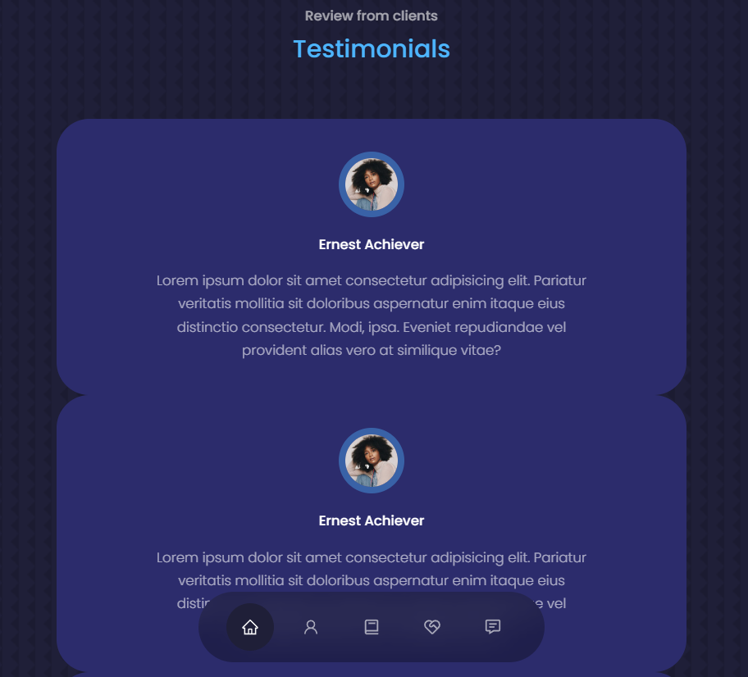

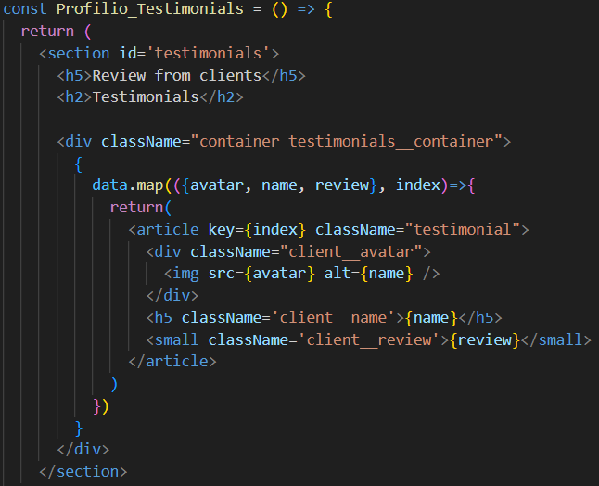 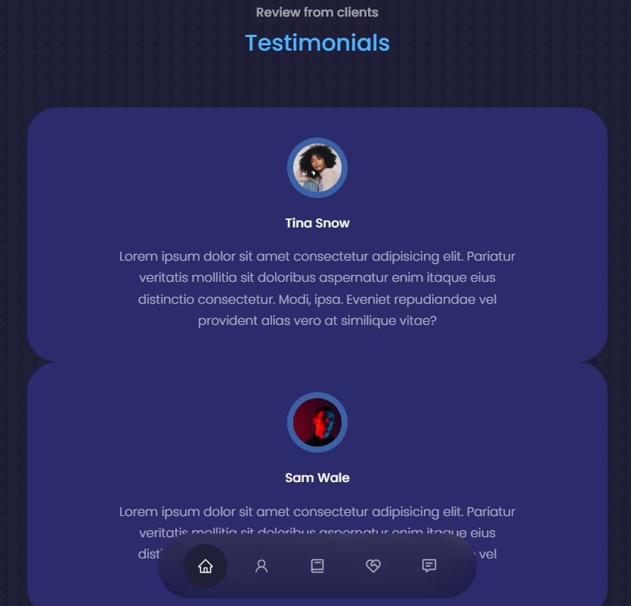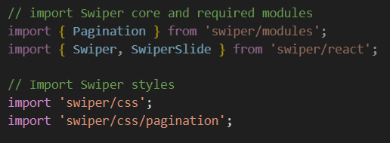 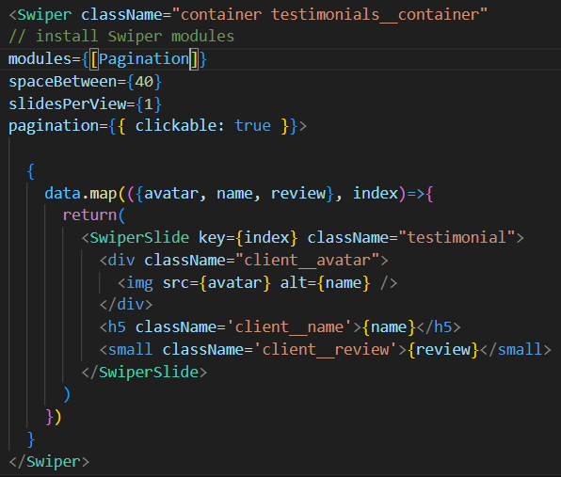 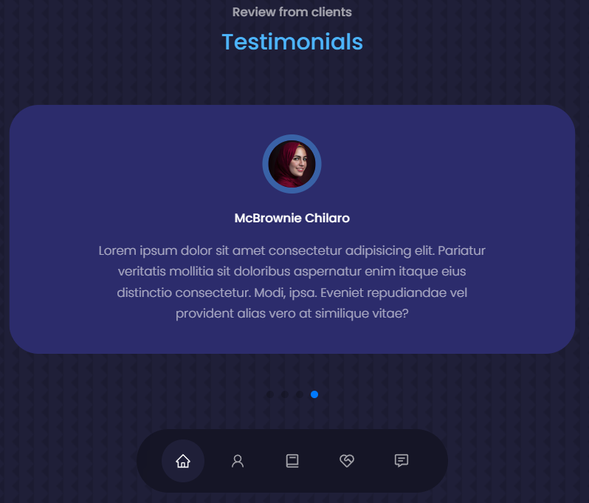

1. Next move to contact, open Profilio_Contact.jsx, build a structure and check browser, write the code, get icon from react icon, set email/facebook/whatsapp api embedded to a link, check browser and functions, afterward, code form, go to css to style the content, check browser, after that, write media query for responsive, check browser to see if it’s responsive, afterward, write contact form function, go to emailjs.com, login emailjs, create email template, save and test it(edited and sent), check gmail (got it), open new tab for react emailjs, install emailjs (npm install emailjs-com—save) and import emailjs to code ( add service_id (click email service)/ template_id (click email template) /public_key (click account), and then test sending message from website, check gmail, it worked, add e.target.reset() in sendEmail function (after sending email, form will be reset)

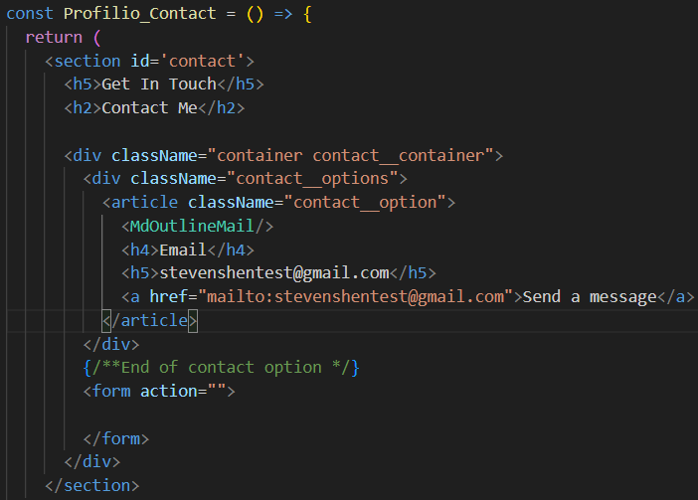

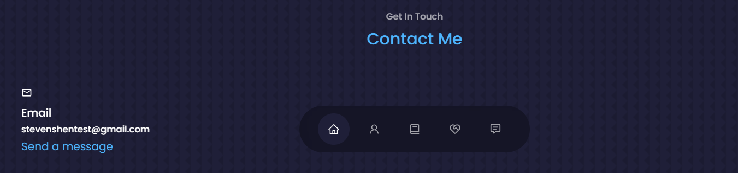

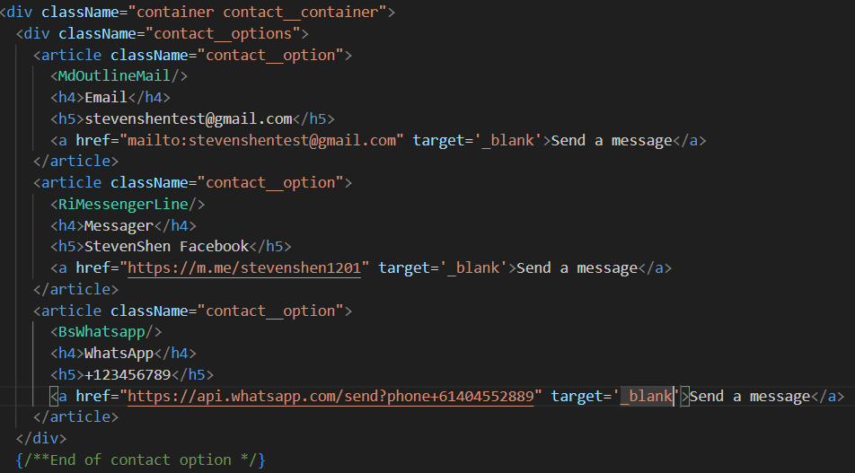 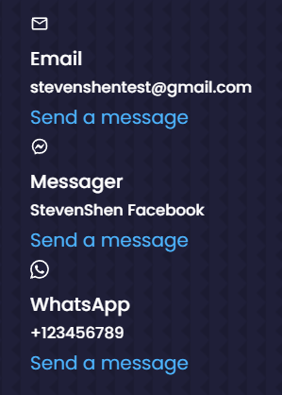

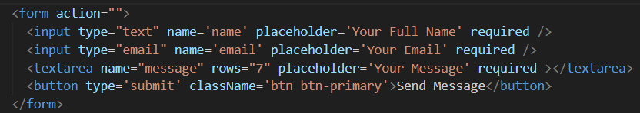

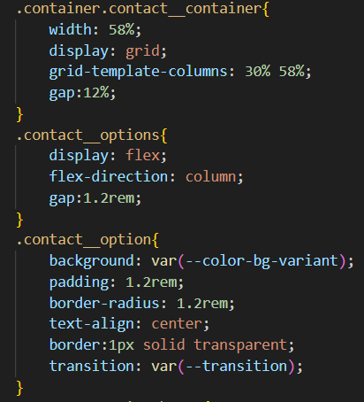 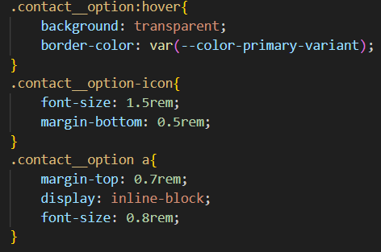 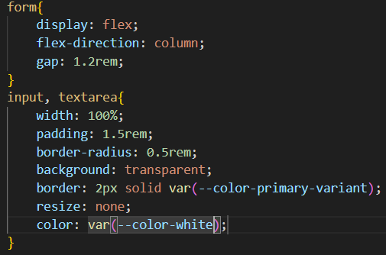

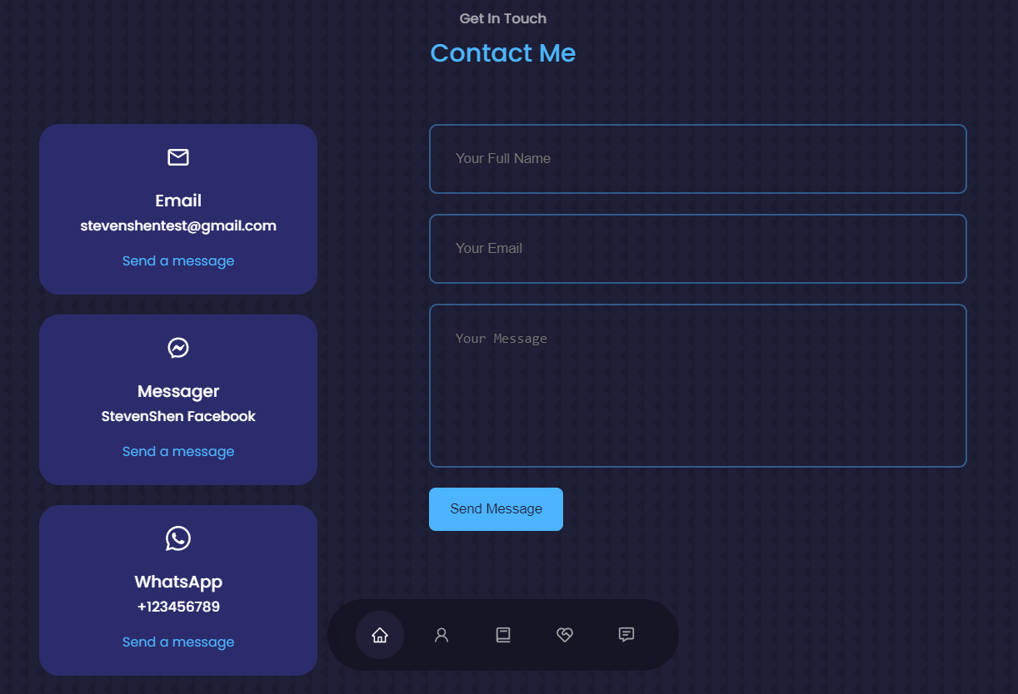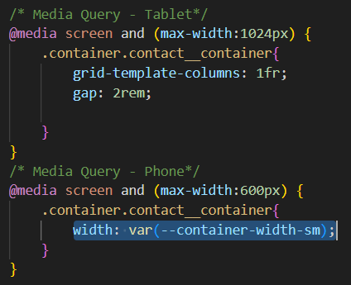

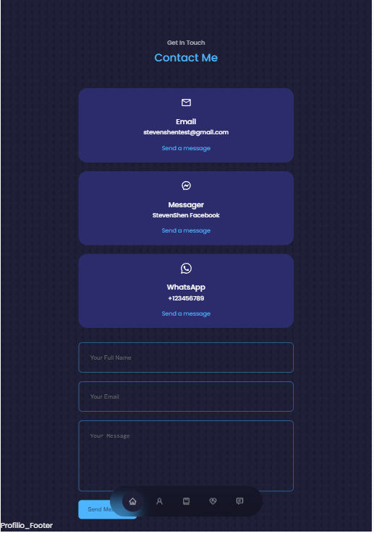 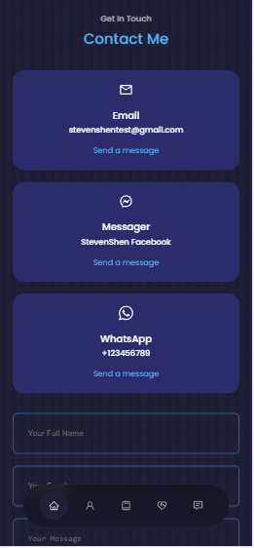

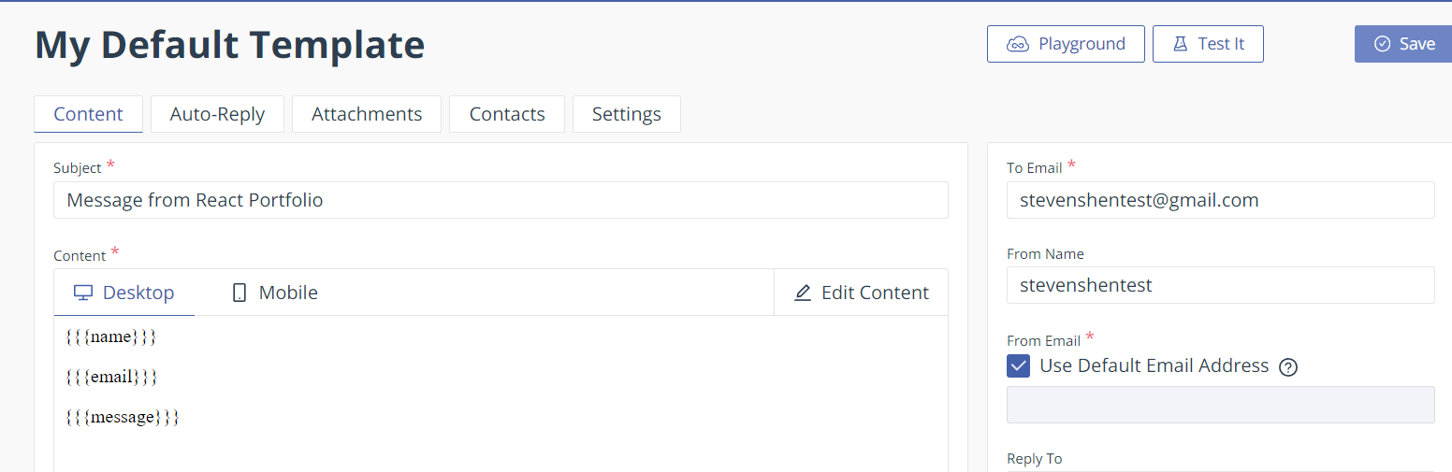

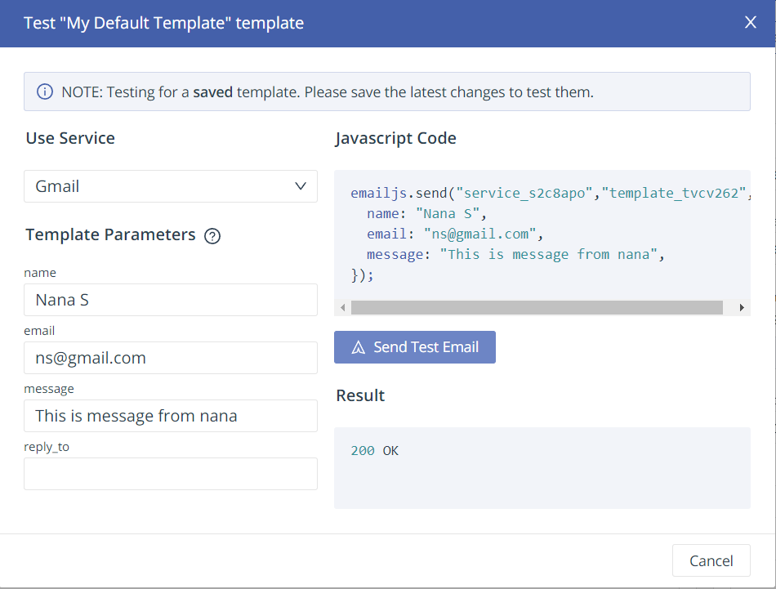 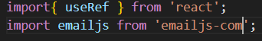

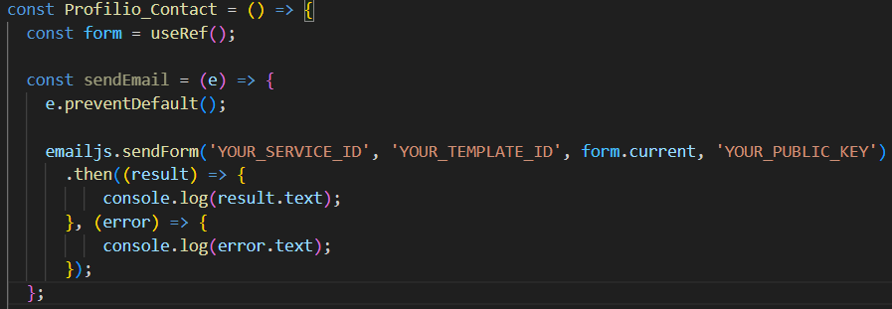

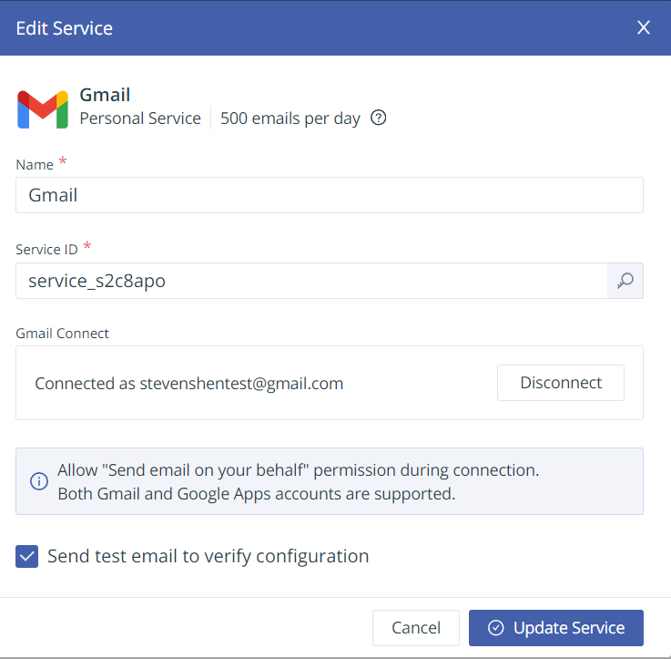

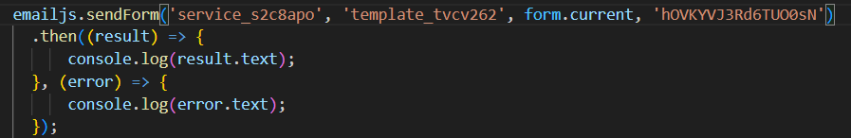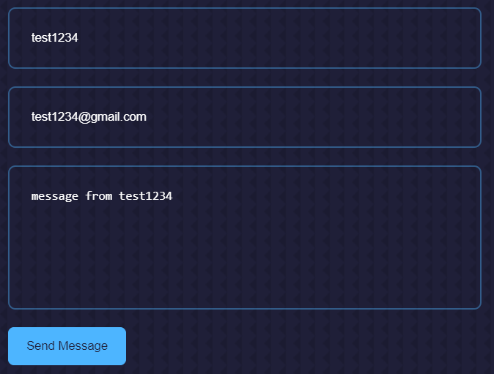 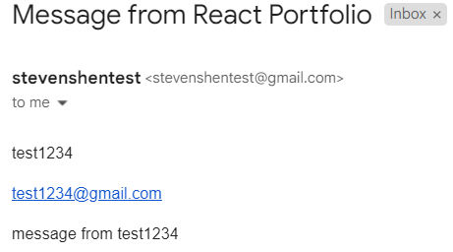

1. Last move to footer, open Profilio_footer.jsx, code structure, check browser, afterward, go to css to style them and check browser, after that, style media query, all completed, last thing to change is Navbar colour, open Profilio_Nav.css, change active (I don’t like changing, changed it back)

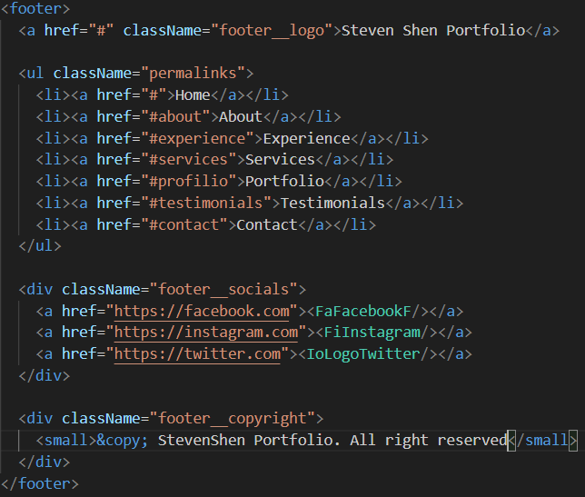 

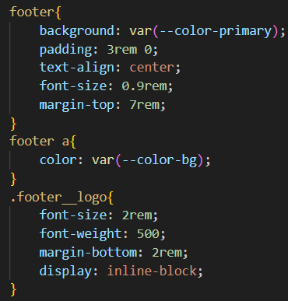 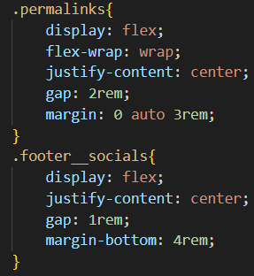 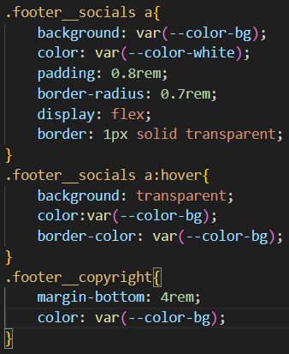

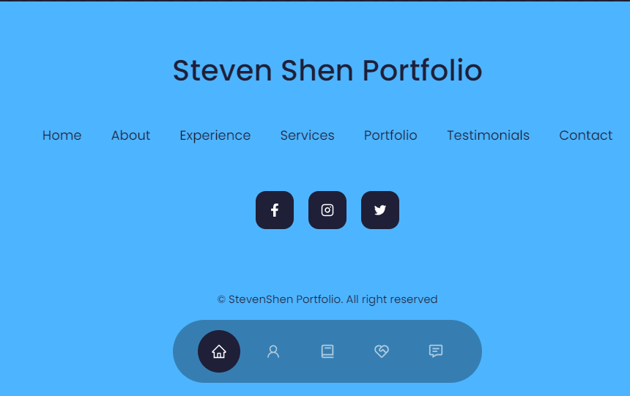 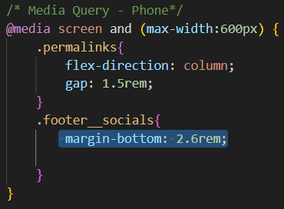

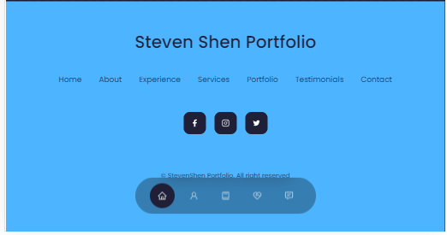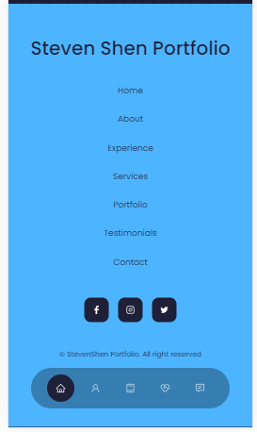

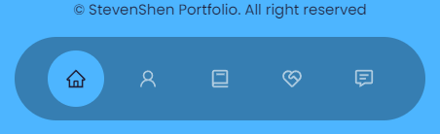

1. Last thing is to deploy on the website, firstly go to package.json, add homepage and save, open another terminal to type “npm run build”, it will build dist (some add build folder), open Filezilla to connect infinityfree, send files inside of dist to htdoc in infinityfree, and testing website, it worked.

